- PROJECT STATEMENT
Whats the app, generally
Why did I pick it
Overview of my app
Project objectives
Challenges

2. RESEARCH
Backgound research, into ADHD and kids
Currently available apps:
ADHD apps
Calendar apps
Organisational apps in general?

- APPROACH AND METHODOLOGY
Order at which we will develop various elements and a section on each
(database design, controllers and views, authentication and authorization, lower priority items, styling and delivery, user feedback and assessment)
4. DESIGN
A. SYSTEM REQUIREMENTS(doesn’t mean specs, it means requirement gathering requirements)
Use cases/requirements matrix
Use case diagram

B. SYSTEM DESIGN
Class diagram
Sequence diagram
Wireframes

5. EVALUATION
6. ISSUES AND RISKS
7. FUTURE WORK
BIBLIOGRAPHY

ADHD Kids
ADHD kids is an android application which advertises itself as “a platform designed to coordinate parents, caregivers or teachers in the follow-up of children under 18 with Attention Deficit Hyperactivity Disorder (ADHD)”. The application is feature rich, attractive and easy to use. The application’s features include:
- Ability to create and manage pharmacological calendars to keep track of medication schedules.
- Plan general activities via a calendar function
- Self-assessment questionnaires for measuring results of treatment
ADHD Kids does not offer the features of the application being created in this project, rather it is a more all-round solution for children and parents of children with ADHD. The application is more focused on ADHD treatments and features surrounding these such as medication management and progress reporting. The reason this application was considered is that it is good to see what kind of features the target audience expects from an ADHD management application, for the purpose of requirements gathering.

Google Calendar
This is the default calendar app that comes pre-installed on android devices, it is also available as a free download from the Google Play Store. The application offers the basic functionality that you would expect plus a few extra features.
Its features include:
- Calendar can be viewed by day, 3-day, week or month
- Connects to multiple google accounts, allowing synchronisation with other google services such as Gmail
- Automatically included birthdays and holidays
- Adjustable time zone
- Distinction between ‘Reminders’ and ‘Events’
- Ability to set up goals
The application is very well designed and easy to use. The ability to link the calendar to multiple google accounts and display events, reminders and goals for all accounts on a single calendar is a great feature, particularly for students, or professionals, who often have multiple email addresses. The scheduling system is very standard, including the features you would expect. The design for the ADHD Mate application will be heavily inspired by googles calendar. The obvious difference being that ADHD Mate will be a shared calendar for parents and children. Google calendar does not offer any calendar sharing functions between multiple users.

Technology research:
Android:
Android is Google’s mobile and smart phone operating system. It is based on the Linux Kernel. Unlike its competitors, Android is open source. The platform has a wide range of applications available via the Google Play Store. Android is the fastest growing mobile operating system with a million users powering up new devices every day. (https://developer.android.com/about/index.html) Android users download over 1.5 billion apps and games from the Google Play Store, every month. From a development perspective, Android is an attractive platform due to its single application model which allows for applications to be deployed on a broad range of devices. Applications can be developed responsively or adaptively so that they can have a different appearance when viewed on a tablet, or large phone, versus a smaller phone. Android applications are developed with java and a full IDE, Android Studio, is available to develop apps on. Android Studio’s features include not only development features but debugging, packaging and sharing functionalities. An android application developed through Android Studio can be pushed to a version control platform, such as Git, with the click of a button.
Google’s Play Store is an open marketplace, meaning that the developer has control over how their applications are sold. This includes freedom to decide pricing, whether subscription, onetime payment, or free, freedom to decide what devices your application should be available for and the freedom to dictate what customers your application should be available to. Play store allows frequent updates and a developer can have an app or update on the market, ready for download within a few hours. Another great feature of the Play Store is that it allows for the release of alpha and beta versions of applications, downloadable from the market by a select group of testers.
Android applications can be developed on a range of platforms such as Windows, Mac and Linux. In contrast, iOS applications can only be developed using a Mac. Registration fees for developers using the Android marketplace are much lower and are a one time payment, versus a subscription fee for Apple’s App Store. (https://www.androidauthority.com/develop-apps-for-android-rather-than-ios-607219/) Another bug advantage of Android as a platform for application development is its market share. According to IDC Quarterly Mobile Phone Tracker, in the first quarter of 2017, Android held 85% of the smartphone market share.

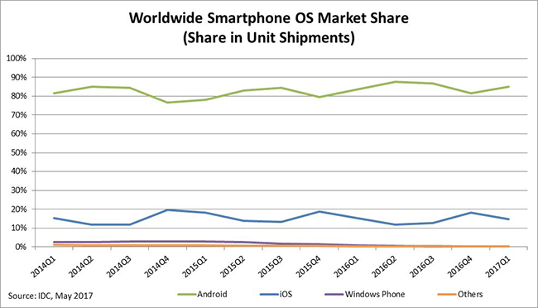
IOS:
iOS is the mobile operating system on Apple devices which includes iPhones, iPads and even iPod Touches. After Android, it is the second most popular mobile operating system. Application development for iOS is done using the Xcode IDE with the iOS SDK. This platform supports multiple programming languages, the current most popular being swift.(“Developing for Android vs developing for iOS - in 5 rounds,” 2016). This language was developed specifically by Apple for iOS and OS X (Apples Operating System for Macintosh computers), it is based on Objective-C. Xcode can also be used with Objective-C, Javascript or Python, among others. iOS development can only be don’t on Mac computers, meaning that both an iPhone/iPad and a powerful Mac computer are necessary tools for the developer.
One advantage to developing for iOS, rather than Android, is the dramatically lower range of different devices and OS versions which are present in the marketplace. When developing for android there are far more differences in terms of screen sizes, DPIs and aspect ratios, as well as other factors such a power consumption and hardware. iOS is only available for a handful of devices, so applications can easily be developed for, and tested on, the entire range of available devices. This is not possible for Android. Beyond device differences, there is also a far wider scope of different OS versions in circulation for Android versus iOS. The below pie chart illustrates this.
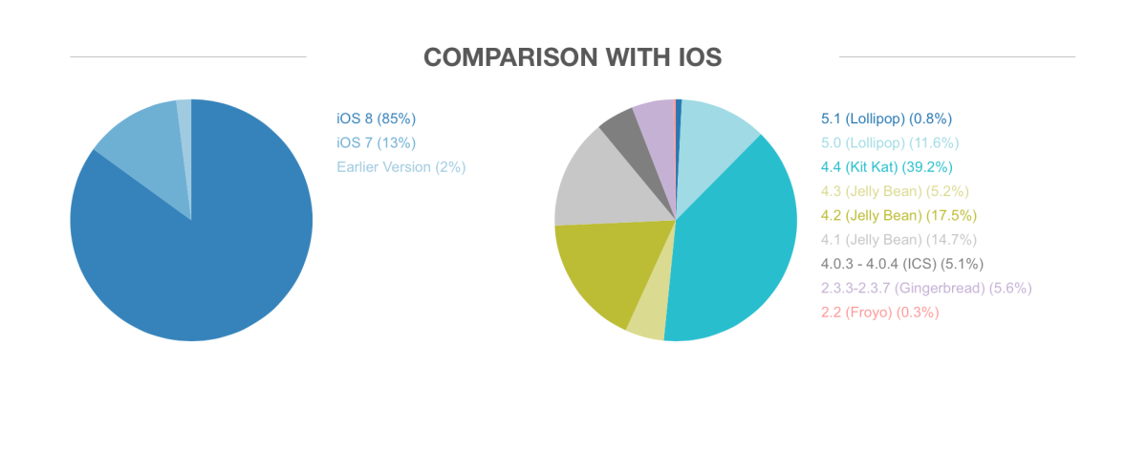
(“Developing for Android vs developing for iOS - in 5 rounds,” 2016)
Caption this
Apple have a much stricter and more rigid publishing system than Android. To publish an application on Apples App Store, you must pay a recurring annual fee of about 99 USD, every year. Also your app must be formally submitted for testing and may be rejected after or during this process. Although the Android Play store has more users than the Apple App Store, the App Store is still the more profitable of the two. This may be due to iPhone users being more willing to spend money on apps, in general.
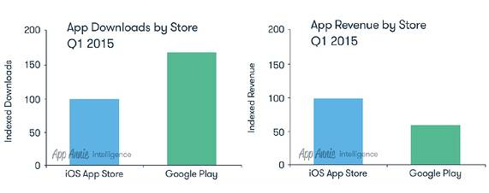
(“Developing for Android vs developing for iOS - in 5 rounds,” 2016)
Caption

Windows:
Windows Phone is a family of mobile operating systems developed for Windows smartphones. The most recent iteration of the range is Windows 10 Mobile, which in itself is a edition of Windows 10, the Windows OS for personal computers. The Windows vision for smartphones and mobile devices is of unified Windows application platform with blurred lines between smart phone/tablet and personal computer operating systems and interfaces. For instance, windows devices can be synchronized as such that a single application can run on multiple devices. Application development for Windows is performed via the Universal Windows Platform, which allows for the development of apps for personal computers, tablets, smartphones, HoloLens and Surface Hub, using a single API set, one app package, and one app store. UWP is flexible and allows for the use of several programming langauges including C#, XAML, Unity, Javascript and many more.
Windows phone falls short of its competition in terms of market share. As shown by the pie chart below Windows phone users make up only 1% of the total smartphone user base. Due to this lack of success, Windows announced in 2017 that they would discontinue development of Windows 10 mobile (Spence, n.d.).

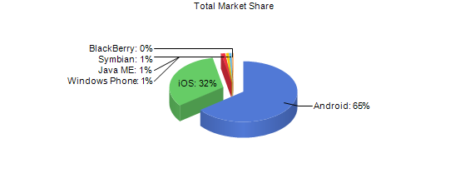
Data from https://www.netmarketshare.com, for this year, 2017.

Conclusion:
The ADHD Mate app will be made as an Android app using the Android Studio IDE for development. There are many factors that influenced this decision including:
- Programming language; Java is a language that the developer is familiar with and eager to expand his knowledge of.
- IDE; The developer is already familiar with Android Studio and enjoys using it.
- Market share; Android applications are available for download to a greater market, and given that this application is not intended to be put on the market as a paid app, the greater profitability of iOS applications is not a factor.
- Available resources/costs; The developer of this application has at his disposal, a relatively powerful Windows laptop, and a medium end Android smartphone, using one of the latest versions of the OS, Nougat. Obtaining the necessary tools to develop an iOS app will require a budget that is not available. Another cost factor is membership/subscription to the app store. Androids Play Store only requires a small one-time payment which can be budgeted in.
- Developer familiarity; The developer is an experienced Android user and a buyer of apps on this platform, familiarity with the platform will be beneficial going forward as the developer understands how Android applications should look and run in order to be up to standards of the apps out there in the market.
- Testability; The developer has much greater access to additional Android devices for testing purposed when compared to either iOS or Windows. This refers to additional devices, apart from the Android Phone owned by the developer, mentioned above.

Data persistence
One of the immediately obvious technologies that will be required for this project is data persistence. Since the app will have user accounts, some kind of database will be required to store these accounts. Authentication will also be needed to ensure users can only log into their own accounts. The following section is an exploration into various database options for this application.

SQLite:
SQLite is “an in-process library that implements a self-contained, serverless, zero-configuration, transactional SQL database engine.”(“About SQLite,” n.d.). It is a Relational Database Management System. SQLite is public domain, therefore free to use privately or commercially. According to its website SQLite is the most widely deployed database in the world. SQLite is a popular choice for memory constrained devices since it can be run in minimal stack space and with a very small heap. It has good performance in general although this is tied to the amount of memory it is given.
Advantages:
- Tried and tested
- Free
- Zero-configuration; no need for installation or setup
- Lightweight, making it a good choice for mobile applications
- Easily queried data

Firebase Realtime Database:
Firebase Realtime Database is a cloud-hosted database which stores data is JSON objects. Data is synchronized in real time to every connected client. Firebase provides an ‘out of the box’ solution for pretty much all data persistence needs, therefore, it is an extremely attractive solution for this project. Firebase is not completely free to use, like SQLite is, however for projects on a small scale, such as this, it is free. With the free plan, Spark, Firebase allow for 100 simultaneous connections, 1 GB of storage and 10 GB per month of downloads. For the needs of this project this is more than enough.

- Capable of supporting cross platform apps where l clients share one Realtime Database instance
- Data remains available when offline and will update when client device re-connects
- Security and data validation available through Firebase Realtime Database Security Rules
- Firebase Authentication allows developers to define who has access to data and how they can access it
- Stores data on the cloud making it available from anywhere
- Free for small projects

The choice of data persistence technology for this project is Firebase. This choice is based on a number of factors but most notably the ease of setting up a Firebase Database. Since Firebase provides ‘out of the box solutions’ for database creation, security and authentication, more time and manpower can be directed towards other aspects of the project, such as the development of the shared calendar functionality.

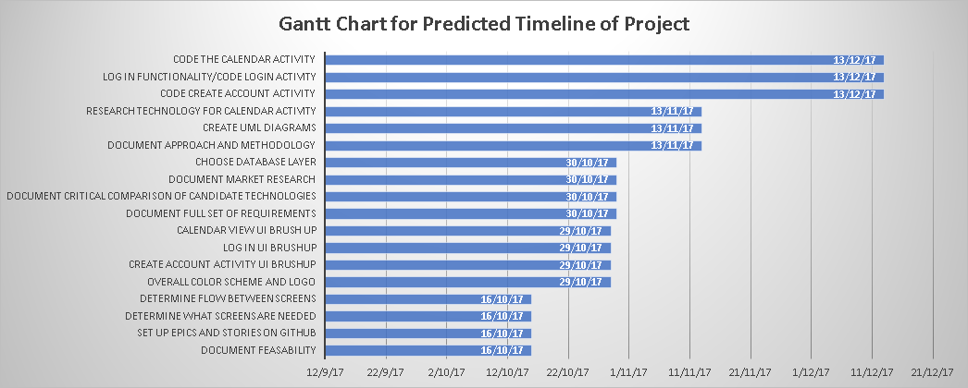

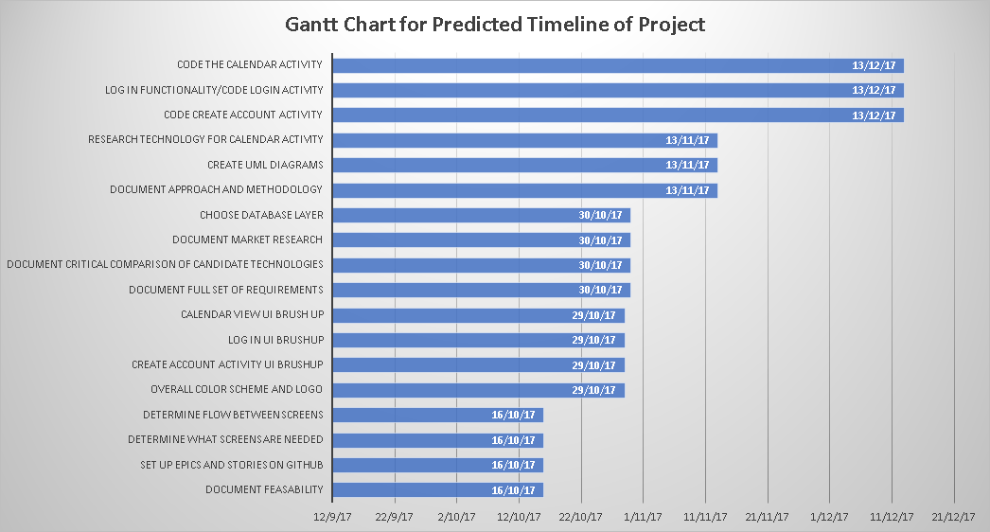

The second factor that influences the ability to pay attention to some tasks but not to others is the relative weakness in working memory that is characteristic of many persons with ADHD. Working memory is essential for keeping in mind relative priorities of our various interests at any given time.
-https://www.additudemag.com/adhd-motivation-problems-getting-started-on-tough-projects/

